Indefensible Spaces

Chapter 2 - Sun Village

Rahim Kurwa (rak@uic.edu)

*This is a draft of Chapter 2 of my manuscript, Indefensible Spaces, Policing and the Remaking of Segregation in the Antelope Valley. The book’s focus is on documenting the political and social forces in Los Angeles’ Antelope Valley that, in the wake of the Great Recession, attempted to prevent Black residents from moving into the valley through the Housing Choice Voucher Program. The cities of the Antelope Valley found that, in lieu of traditional modes of racial segregation, they could use policing as a mechanism to surveil, regulate, and terrorize Black voucher renters, eventually evicting or otherwise forcing them out. Tenants and activists in the valley used local organizing and national fair housing litigation to resist and partially defeat this attempt to re-engineer racial segregation.*

*This chapter focuses on the history and context preceding the events described above. I trace the long history of Black residency and organizing in the valley and the struggles and successes of its civil rights leaders during an earlier era of segregation. In this manner, I hope to both expand the history of Black Los Angeles and illustrate how important this periphery is to understanding Los Angeles’ development, racial politics, and housing landscape.*

**Chapter Outline**

**Enforcing Segregation** **4**

**Enforcing Scarcity** **7**

**The Antelope Valley’s Military Social Democracy** **10**

**Creation from Segregation: Sun Village** **13**

**Images** **30**

Charles Graves was born into slavery in Kentucky in 1856. After his father was killed during the Civil War, Graves decided to move west. He traveled mostly by rail until he reached the Antelope Valley, a high-elevation desert region between the Sequoia and Angeles Forests, at the far west edge of the Mojave Desert. Graves settled down in one of the northern cities of the valley, Rosamond, in 1882, a few decades after Peter Burnett’s legislative and gubernatorial campaigns to ban Black residency in the state and a few decades before Colonel Allen Allensworth established the eponymous all-Black colony 120 miles to the north.[1],[2] Graves stuck it out through the years-long drought that collapsed several valley colonies, building a cattle ranch, becoming the city’s postmaster, and striking gold in two of the region’s many small mines. His success allowed him to build Rosamond’s first school, which he did with his wife Cordia Anita Roberts in 1908 – not twenty years after the landmark *Wysinger v. Crookshank* ruling that barred California cities from explicitly segregating public schools.[3] Graves died in Lancaster thirty years later, but sites across Rosamond – including a public school in the same location as his first one-room attempt – still bear his name.[4]

A century later, historian Mike Davis described the Antelope Valley as the last frontier of the Southern California dream.[5] The “militarized desert,” which had once boomed as a site of aerospace construction during and after World War II, remained relatively underdeveloped into the 1990s, even as Los Angeles continued its rapid growth.[6] Davis described the white residents of the valley as “frantically trying to raise the gangplanks” to stop the influx of poor Black and Brown Angelenos pushed out of the city as a result of the pro-growth policies put in place by the very business and political elites that the right-leaning region so staunchly supported.[7] But as Graves’ biography illustrates, it isn’t possible to raise the gangplanks against people who are already on board, much less who have been there for generations.

This chapter is about the first large wave of Black migration to the Antelope Valley, a process that occurred in the 1940s, 50s, and 60s as Black Angelenos moved to the valley to take jobs in the valley’s booming aerospace military industry and evade the city’s entrenched structures of racial segregation. Blocked from renting or purchasing property in the valley’s main cities Lancaster and Palmdale, they built a town called Sun Village on its periphery. It quickly became a site of community building and civil rights organizing, culminating in its residents breaking the wall of residential segregation, what had been the key fulcrum of racial hierarchy in the valley for decades.

I argue that these events were the product of two forces. First, after the war, Los Angeles County used the Antelope Valley to capture military investment that was being marked for non-urban areas. This allowed the county to continue to enjoy significant federal investment as well as the economic activity and taxes that flowed from it. Through this investment it provided white Angelenos good jobs and subsidized, segregated housing in the valley.

Second Los Angeles was forcing Black residents into a housing crisis by enforcing racial segregation and thwarting the construction of public housing. The city’s commitment to racial segregation denied Black families housing outside of the South Central Corridor. I trace these pressures through an examination of the lives of George Washington Prioleau and his wife Ethel Prioleau – a family that sought out Los Angeles as a refuge from racism, but who were nevertheless dispossessed of their home in the Bruce’s Beach development. Meanwhile, the city also thwarted demands for public housing, denying its residents a solution to the crisis through public investment. The twin pressures of segregation and scarcity pushed some Black residents to consider moving to the city’s peripheries, escaping the city’s restrictive covenants and obtaining jobs in the service sector of the valley’s aerospace industry. Thus began a first wave of Black migration to the valley and the construction of Sun Village.

After tracing the forces that led to the creation of Sun Village, I return to the Prioleau family to show how these forces affected one Los Angeles’ family’s generational trajectory. The Prioleaus’ youngest daughter, Lois, was among the first generation of Black families to migrate to the Antelope Valley in its mid-century boom. She and her husband Patrick became leaders of Sun Village’s civil rights movement, founding the local NAACP chapter, helping to establish the nation’s first public park dedicated in honor of Jackie Robinson, and eventually becoming the first family to break the valley’s wall of segregation by moving into Palmdale.

This history helps expand our understanding of Black Los Angeles both over time and across a broader geography of settlement and struggle. At times Sun Village has been a place of freedom from restrictive covenants, a place to build community resources, and a site of Black civil rights organizing and popular mobilization. Crucially, those who participated in these efforts emerged from and remained connected to the larger freedom struggles of Los Angeles’ core. But Sun Village was by no means the only periphery of Los Angeles that became a site of Black struggle, and its history can be productively linked to peripheries around the region that played such a role. Sun Village should be seen as part of an archipelago of Black places in Allensworth, San Bernardino, Lanfair Valley, Coachella, Victorville, and Indio.[8]

Finally, this history contextualizes the contemporary subject of this book, the Antelope Valley’s 2000s-era efforts to police and evict Black Section 8 voucher renters from the valley. Seen in isolation, that story might be understood as racial backlash, but in the broader context suggested by Davis and extended back through the 1900s, it becomes legible as a continuation of its historic racial and political contestation, namely the white community’s persistent desire to prevent that which had already happened. The complete racial segregation of the Antelope Valley was defeated in the 1960s, but as chapters to follow will show, the afterlives of this system are still found in the valley’s political, economic, housing, and punishment systems.

# Enforcing Segregation

Charles Graves was among fewer than 200 Black residents of Los Angeles County at the end of Reconstruction. But as Los Angeles grew, the Black population in the county grew with it, reaching 1,817 by 1890, 9,424 by 1910, and 18,738 in 1920, while the county itself grew to half a million in population.[9] This growth occurred within two key constraints: the city’s commitment to racial segregation and opposition to public housing. These commitments locked Black Los Angeles into conditions of segregation and scarcity, key factors that drove some Black Angelenos to seek out the Antelope Valley and other peripheries as alternatives.

The city’s white population, represented by homeowners’ associations, KKK and other violent collectives, and the whites-only real estate association, steadily built legal and social barriers to Black residential integration. They used restrictive covenants to prevent Black purchases, and when that was struck down by courts, re-wrote covenants to instead forbid Black residents from occupying homes. Meanwhile, real estate agents refused to show properties in white neighborhoods to Black purchasers, and whites individually and communally used violence to maintain segregation. These forces worked to block Black residency outside the Central Avenue corridor. One family that moved to Los Angeles and found itself on the other side of that line was the Prioleaus.

Major George Washington Prioleau was born to enslaved parents on May 15, 1856, in Charleston, South Carolina. As a young adult he attended Wilberforce University in Ohio, majoring in theology and beginning service as a pastor in an A.M.E (African Methodist Episcopal) Church. Prioleau quickly rose to prominence. By 1889 he became a professor of theology at Wilberforce, and in 1895 President Grover Cleveland appointed him chaplain of the 9th cavalry in the US Army, one of the segregated Black Army regiments that came to be known as the Buffalo Soldiers. Prioleau was disaffected by his experience in the military, having encountered severe racism during his army recruitment work in the American South. As Trevor Goodloe documents, “Through public letters and editorials, Prioleau challenged racial segregation and attacked the hypocrisy of fighting a war for liberation in Cuba while the United States remained locked in a mindset of racism,” something the soldiers experienced on a regular basis when denied seating at restaurants and jeered at by whites. Eventually, “he concluded that patriotic duty and military service would not erase the color line in the minds of many whites.” He left the army in 1920, retiring as a Major, and he and his wife Ethel Stafford Prioleau retired to the plot of land they had recently purchased in a part of Manhattan Beach known as Bruce’s Beach.

Bruce’s Beach was an important site of Black placemaking in the Los Angeles area, a tract of land roughly spanning Ocean Drive to its west, 27th Street to its north, Highland Avenue to its East, and 26th Street to its south. The tract was subdivided into blocks, and again into lots for home construction. In May 1912, Willa and Charles Bruce purchased Lot 8 of Block 5 (and later plot 9 in 1920), building a seaside resort that included a cottage where visitors could purchase lunch, rent swimming clothes, and shower. The resort quickly became popular, attracting Black visitors, beachgoers, and vacationers, and even new residents who bought their own plots in the development. And Bruce’s Beach was not alone; Black residents were building spaces of freedom at various sites on the margins of Los Angeles. In 1922, Nolie and Lela Murray purchased 40 acres in the Bell Mountain area of Apple Valley, building what would come to be known as Murray’s Dude Ranch, a desert resort area for Black travelers from across the country, and vacationers from Los Angeles.[10] And in 1924, residents built a recreation and resort area named Valle Verde, located at the site of a former colonial settlement at the base of the Topatopa mountains just west of present-day Santa Clarita. Valle Verde attracted Black residents from across Los Angeles who were otherwise blocked from accessing public parks, recreational facilities, and beaches in the city.

George and Ethel Prioleau purchased the southern half of Lot 4, Block 12 of Bruce’s Beach in 1919, a few streets east of Bruces.[11] They began to attend the First African Methodist Episcopal Church founded by Biddy Mason, at its early 8th and Towne location downtown, but soon came to believe that Black residents on the westside needed a church that was closer than the First A.M.E. Church. They established the Bethel A.M.E. Church at 1511 West 36th Street in 1921. Major Prioleau devoted himself to the church, serving as pastor without taking a salary and working on the building. In June of 1924, the Prioleaus had their last child, Lois Emma. In 1927, while painting the church, Major fell from a ladder, sustaining internal injuries to which he would eventually succumb on July 15.[12]

White residents of Manhattan Beach were determined to evict the half dozen families living in the Bruce’s Beach area. As early as 1915, they complained to the city council of colored families gathering at Bruce’s Beach for picnics and leisure. Led by real estate agent George Lindsey, who characterized Bruce’s Beach as “negro invasion,” the city began to search for legal means to evict its residents.[13] White families added to the rhetoric of invasion the argument that the presence of Black families would decrease their property values. By 1924 the city council passed an ordinance seizing the land by eminent domain for the purposes of building a park. The Bruces responded by suing the city for racial discrimination, but it was to no avail. Violence against Black residents in the area was rising, with KKK members committing arson and later lighting a burning cross in front of one Black family’s home. By 1929 all the Black property owners of the condemned lots had been forced to accept buyouts, knowing that violence would only escalate if they remained. The Bruces received $14,500 for Lots 8 and 9 on Block 5, and the Prioleau family received $1,874.37 for their portion of Lot 4, Block 12. Ethel Prioleau moved the family to another property in Manhattan Beach, but soon found their claim to that home threatened by a restrictive covenant. The family eventually relocated to 35th Place, near the Bethel AME Church it had established.

Black activists and organizations across Los Angeles continuously fought against racial segregation throughout this period. The NAACP, Urban League, California Eagle (led by activist and publisher Charlotta Bass), and others used collective action, political pressure, and legal challenges to steadily chip away at the city’s segregation structures during the 1920s, 30s, and 40s. They challenged restrictive covenants, protected Black homes from attack, ensured collective awareness of social issues, and devised novel challenges to segregation.

The efforts extended to challenging segregated public accommodations as well, and it is here that the Prioleau family’s legacy of struggle reappears. As Douglass Flamming documents, Los Angeles began to officially segregate its public swimming pools in 1925. Early efforts to challenge the policy had foundered, having been met with rulings that the city had reasonably provided separate but equal accommodations; the NAACP hesitated to try again for fear of a court setting a negative precedent. But Betty Hill, a founding member of the Los Angeles NAACP chapter, decided to press on with a campaign to desegregate public swimming pools, even if she lacked formal institutional support. She recruited her neighbor, Ethel Prioleau, to send her children to the Olympic Park pool on a “whites only” day.[14] Once turned away, Prioleau had grounds to sue, and Hill did so on her behalf. By 1931, judge Walter S. Gates ruled in their favor, finding that the city’s segregatory pool policy was unconstitutional and ordering it to be ended.[15] The victory was seen as a triumph with enormous meaning for civil rights struggles far beyond California, and Hill and Prioleau continued to work together in the years that followed, campaigning against segregation through the Womens’ Political Study Club.

# Enforcing Scarcity

During this time, the city’s rising labor and civil rights groups also fought for the construction of public housing as a solution to the city’s racialized housing shortage. In 1934, a Works Progress Administration survey described the city’s housing stock in dire and dysfunctional terms, noting overcrowding and slum conditions in much of the city’s buildings, with shantytowns dotting the Los Angeles River. Patterns of poor housing quality coincided with the city’s quickly entrenching patterns of racial segregation. At the national level, the trends were the same, leading to increased pressure for federal action. After the courts blocked the Public Works Administration’s slum clearance and public housing efforts, the Roosevelt administration passed the first federal public housing legislation. The 1937 Housing Act authorized the construction of public housing that would replace slum conditions with what it envisioned as decent, safe, and sanitary housing.[16] And the federal government authorized the creation of local Public Housing Authorities. As agencies of local governments, they could use eminent domain to acquire land for construction, then proceed with that construction using federal funding and backing.

From the start, California’s conservative political actors were hostile to public housing. Republican Governor Frank Merriam vetoed the state bill that would enable state and local agencies to make use of federal public housing funds three times.[17] But faced with enormous federal incentives and public pressure “from labor, civic organizations, religious groups, and mobilized groups within the city’s racial and ethnic communities” to build housing, the city enabled a local housing authority. The Housing Authority completed its first project, Ramona Gardens in Boyle Heights, in 1940.[18] Ity would go on to build 10 projects under the 1937 Housing Act, including Pico Gardens, Pueblo Del Rio,[19] Estrada Courts, Aliso Village, and others along the city’s east and south side corridors.[20] Construction was accelerated by the need to accommodate war workers. By 1945, more than 53,000 residents were living in 12,275 units of public housing.[21] Following federal guidelines, their racial composition and distribution had been carefully calibrated to match existing patterns of segregation. Yet another 100,000 residents had applied for public housing but could not be accommodated. This enormous need for housing was driven by the city’s growth through the 1930s and 1940s, partly as a result of the Great Migration, and partly as a product of the growth of wartime industries. The city more than doubled in size between 1920 and 1930, surpassing 1.2 million residents. It reached 1.5 million by 1940 and nearly 2 million by 1950. Los Angeles’ Black population took a similar trajectory, growing from just under 20,000 in 1920 to roughly 200,000 by 1950.

The system of racial segregation locking Black families out of large parts of the city coupled with insufficient production of public housing fueled a prolonged housing crisis, which Black organizations and leaders responded to with demands for fair housing as well as campaigns for more public housing.

The public housing movement was bolstered by a spirit of progressivism that viewed decent housing as the foundation of a healthy community and a strong city.[22] The speedy creation of a public housing authority in Los Angeles in order to take advantage of federal funding offers was animated by what Parson cites as a popular desire for social democratic reform. But shortly after the program began working to identify sites for construction, the Authority was met with conservative and business opposition, which framed public housing as a dangerous step towards socialism. The anti-public housing campaign successfully managed to stifle the movement, leaving Los Angeles with a relatively small stock of public housing that in no way resembled the scope of housing built in comparable cities like New York and Chicago. What housing was built largely matched emergent patterns of segregation and spatial disadvantage, with most projects located in South Central Los Angeles or East Los Angeles, or in predominantly Black neighborhoods in Venice, like Oakwood.[23] Coupled with the practice of matching public housing residency patterns to existing patterns of racial segregation, public housing doubled down on racial segregation.

In addition to opposition from the right, public housing was constrained by the fact that the 1937 Housing Act had not provided enough funds to build public housing in sufficient quantities in Los Angeles or anywhere across the country. So one way public housing expanded in the city was by piggybacking on the war effort. As Los Angeles’ war economy continued to grow, so too did pressure to house workers deemed essential to the war effort. Authorized by the Lanham Act and administered federally by the Federal Public Housing Authority and locally by the City Housing Authority, the city “converted nine of its ten original projects into defense housing,” and built an additional “five permanent and twenty-one temporary public war housing projects.”[24] After the war, many of these projects were converted (or converted back) to public housing. In this manner the geography of the war industry and its housing needs deeply shaped the geography of its Black residents.

Between the Housing Authority’s own efforts and its acquisitions of former defense housing, it still could not build enough public housing to solve the crisis. In response, a wide coalition of groups in Los Angeles turned to other levers of housing production. A public housing coalition made up of civil rights groups like the NAACP and the National Negro Congress, labor groups like the Los Angeles Building Trades Council, the California State Federation of Labor, the California CIO Council, and political groups like the Progressive Citizens of America wrote a statewide proposition that would create a state housing authority authorized to use state finances to supplement local public housing construction. The measure – 1948’s Proposition 14 – was supported by public housing tenant councils, the American Veterans Association, Americans for Democratic Action, and the American Jewish Congress. But it was opposed by the *Los Angeles Times*, big business, and real estate associations. That well-funded opposition, and the red-scare tactics it tapped into, defeated Proposition 14 by a 2-1 margin in November 1948.[25] Two years later, voters in the state approved Proposition 10, a referendum to add an additional hurdle to the construction of public housing by mandating that no new public housing could be built without electoral approval of local voters.[26]

Sufficient federal funding for the large-scale construction of public housing only came in the 1950 update to the Housing Act. It was used in cities around the country, but in Los Angeles, the city’s right wing had choked off the possibility of using those funds in a substantial way. Incidents of veterans denied housing due to their political activity, the dashed promise of the Elysian Park Heights Project and subsequent razing of Chavez Ravine to build Dodger Stadium, and a range of other reactionary moves against public housing had decimated its support within the city’s political class.

Like the struggle against segregation, the campaign for public housing showed how difficult it was to achieve a measure of housing justice in Los Angeles. But this did not mean that the government would never pour resources into housing construction for Los Angeles families. Antelope Valley’s coming boom would illustrate that if it served the needs of the white majority, there was no limit to the public investment that the government could muster.

# The Antelope Valley’s Military Social Democracy

For a time, the Antelope Valley remained a stranger to these developments. Its lack of access to water kept it sparsely populated and stifled any major economic growth, save for gold mining and relatively low-water alfalfa farming. But in the 1930s, the valley’s farmers developed new wells that could solve the region’s irrigation problems. Now, the vast expanse of high desert could begin cultivating pears, apples, almonds, and livestock; soon it was marketing itself as “the bread basket for the future Los Angeles.” As its land and speculative value increased, it became clear that Antelope Valley’s existing links to Los Angeles (the old Mint Canyon Boulevard and Bouquet Canyon Highway) were insufficient. The county authorized new highway construction that would connect Los Angeles both to the Antelope Valley and similar developments on the other side of the San Gabriel Mountains.

Throughout the early 1900s, Los Angeles relied on convict labor to build some of its most important infrastructure. Arresting vagrants en masse using the state’s harsh anti-vagrancy law, the city put these convicts to work paving downtown’s dirt streets and facilitating the rapid economic development of the area.[27] The same process unfolded in the effort to link the Antelope Valley to the urban core. Angeles Forest Highway construction started in 1932, and was carried out by convict labor.[28] A county detention camp began the preliminary work, after which additional county funds were provided and additional labor was sourced from prisons. By 1936, three prison camps were being used to staff the construction project, which when completed shaved 20 to 30 miles from the existing routes to the valley.[29]

These preliminary connections made it possible to envision more growth for the valley. Over the next several decades that growth would overwhelmingly come from military investment. The valley would come to represent a cunning solution to a post-war crisis in Los Angeles. The region’s industrial development advantages had made it a hub of aerospace and defense industry development, but war planners also grew concerned that the concentration of development in major cities left them vulnerable to attack. The “defense decentralization” imperative threatened to deprive Los Angeles of critical economic activity by relocating investment to other cities in the Sunbelt. But the valley presented a solution – offering decentralization while still allowing the county to capture its economic rewards in the form of investment, jobs, and tax receipts.[30]

In 1941, the Civil Aeronautics Authority, Works Progress Administration, and U.S. Army selected Palmdale as the site for a major airport and aviation training school, setting it on the path of military development that would shape its next several decades. The initial federal investment of $315,000 was followed that decade by hundreds of millions of dollars to expand the small bombing range and landing strip known as Muroc Field into a major site of wartime training, an installation now known as Edwards Air Force Base.[31] To house these Air Force personnel, the region needed federal housing assistance. And to reach full employment, the region needed Black workers. While the red scare had halted one form of public housing in the city, in the Antelope Valley, the booming post-war aerospace economy saw a new boom of federal housing construction – but again for aerospace and military workers. The post-war movement of Black Angelenos to the valley would soon reveal that this suburban, militarized form of public housing was segregated too.

In February 1943, the South Antelope Valley Press reported that Lancaster would soon be getting its first federally built housing project, Lancaster Homes.[32] The project was “the first civilian family housing project in the United States to be authorized by the Defense Plant Corporation and the Army Air Force.” It constituted 20 buildings of four apartments each for families, alongside two additional buildings – one for single men and one for single women. The housing was built by the Defense Plant Corporation and spearheaded by the Polaris Flight Academy, which needed to provide housing for flight instructors, mechanics, and other training base workers. That Los Angeles was fighting public housing in the city but building it in the valley speaks to the narrow and militarized conditions under which it was ready to accept elements of social democracy.

This process of the war industry locating more plants in the valley and then building more housing to accommodate their workers continued throughout the decade. Another major plant was announced in 1943 for B-25 bomber construction. By 1946, the press was talking of a building boom forecasted for the Palmdale area, spurred mainly by the Civilian Production Administration which was authorizing funds for the construction of 100 private homes in the valley. The expansion of Edwards Air Force Base pushed the Federal Housing Administration to repurpose the Palmdale Air Base into another housing project for 50 families.[33]

In 1946, Lockheed announced plans to relocate a flight assembly line from San Fernando Valley to 50 acres of land in Palmdale.[34] The next year, World War II ace Chuck Yeager broke the sound barrier at Muroc Field, drawing national attention and catalyzing the flyboy mythology of the desert region.[35] Development in the form of schools, additional housing, small businesses, dam construction, sewer lines, and trash collection grew in correlation to this investment, enabling Lockheed to invest again in the 1950s, this time $1.3 million to build a jet fighter plant.[36] In 1952, the army announced plans for $50 million in future spending on air force industry construction.[37] And the ongoing boom necessitated another round of federal housing creation, this time with the FHA permitting the construction of 1200 homes. The homes were to be sold or rented under relaxed credit standards to defense workers and members of the armed forces including Army, Navy, and Air Force servicemembers, and employees of Lockheed, Northrup, Douglas, and other military contractors who were also building hangars and other infrastructure in the region.[38] Within a month, 12,500 had applied for the homes.[39] The post-war boom grew Palmdale’s population by 83% percent between 1950 and 1953, [40] when the city’s population topped 5,000 people living among an estimated 1449 homes.[41] The next year, Lockheed was showcasing its XFV prototype (a plane built for the Navy that would take off and land vertically) while Corvair was announcing plans to build a $2.5 million facility for F-102 interceptor jets for the Air Force. The FHA stepped in again that year, using Title IX of the Housing Act (empowering the construction of housing in critical defense areas) to issue an additional 600 mortgages for the valley.[42] Despite federal desegregation of the armed forces, Palmdale and Lancaster’s whites-only nature remained rigidly intact through the military boom years of the forties, fifties, and sixties.[43]

# Creation from Segregation: Sun Village

In 1961, President John F Kennedy selected Ed Dwight to begin training to be the nation’s first Black astronaut. Dwight grew up near an airfield in Kansas City, watching pilots fly planes and mechanics repair them. He joined the Air Force in 1953, quickly rising to the top of his class, earning rave reviews from instructors and superiors. And so it was an unsurprising surprise that he was chosen for astronaut training – stunning that any Black man was selected, but logical that it would be Ed Dwight.

NASA training took place at Edwards Air Force Base, in the northern part of the Antelope Valley, meaning Dwight landed in a region defined by white economic, political, and social power, perpetuated by what Bishop Hearns called “the same old Mississippi ideas.”[44] No one more powerfully symbolized the valley than Chuck Yeager, who had become flight school commandant by the time Dwight arrived. Yeager had made the Antelope Valley famous, but was now being usurped by a Black man with national press attention like the valley had never seen – Dwight was invited to speaking engagements, given awards in the city, asked for photographs, and interviewed by magazines. And so Yeager, buttressed by the rumors that Dwight had been chosen for his race rather than his capabilities, determined not to let him succeed. In a 2019 interview with the *New York Times*, Dwight recalled learning that on the day he arrived, Yeager promised the base, “We can get him out of here in six months. We can break him.” As training continued, Dwight recalled,

*“Every week, right on the dot, he’d call me into his office and say, ‘Are you ready to quit? This is too much for you and you’re going to kill yourself, boy.’ Calling me a boy and I’m an officer in the Air Force.”[45]*

The story from there becomes murky. Even in a video interview half a century later, Dwight does not speak directly about his treatment, though the Air Force has obliquely apologized for it. But one thing is clear: Ed Dwight couldn’t get to the moon from the Antelope Valley. Though he graduated from the training, he knew he had somehow been stonewalled by Yeager and Edwards Air Force Base. So he left the service in 1966, entering private life before becoming a world renowned sculptor. It would take until 1983 before Guy Bluford became the first Black astronaut to reach space.

Whatever NASA leadership thought at the time, in the light of history it seems obvious that Ed Dwight was never going to be allowed to succeed in the Antelope Valley. Racial hierarchy was the dominant organizing principle of the valley from the very start of its military industrial boom. In some ways, one might say that the valley temporarily achieved a system of apartheid that was more complete than Los Angeles itself. With few exceptions – the Charles Graves’ children, for instance continued to live in Rosamond – Black workers whose labor was necessary to the region’s white wealth were completely segregated within the valley – clustering just east of Palmdale in what was to become known as Sun Village.

But the product of segregation is so often creation, and in the valley Black residents responded to segregation by creating Sun Village. The post-war boom of de-segregated defense industry jobs offered an alternative to the low wage labor and discriminatory hiring practices of Los Angeles proper. Unable to purchase or rent homes in Palmdale and Lancaster, Black workers often had to find difficult workarounds. Peg Lee, a retired administrator of the Jackie Robinson Park in Sun Village, recounted that Black workers from Watts and Compton would commute to the Antelope Valley for work, or sometimes find temporary accommodations during the week before returning to the city on weekends. Daisy and Oscar Gibson exemplified the problem. Oscar was the first Black employee of the Shopping Bag grocery store in Lancaster, but had to commute from Los Angeles, a trip that took two hours each way before better roads and highways were built.

This unsustainable dynamic found the beginnings of a solution in the late 1940s when Melvin Ray Grubbs partnered with the white owners of the Sun Village Land Corporation to sell 1,000 acres of land 5 miles east of Palmdale.[46] Grubbs was a Black lawyer who moved from Chicago to California to begin working in real estate. Through his company, Sun Village Incorporated, he made the lots available for purchase by Black families.[47] Oscar and Daisy Gibson were part of this trend, moving to Sun Village in 1959.

Newspapers covered Sun Village early on. A 1947 headline in the *South Antelope Valley Press* read: “Colored Sub-Division Being Promoted East of Palmdale”.[48] Sun Village meant the chance to buy land and build a home outside of the structures of racially restrictive covenants. And even after 1948 *Shelley v Kraemer* ruling invalidating the enforcement of restrictive covenants, it continued to represent a place of relative and contingent housing freedom, free from the discrimination of real estate agents and the California Real Estate Association’s discriminatory guidelines, free from HOLC’s redlining, free from discrimination by white sellers and renters. Lee explains, “When they couldn't build their home in Watts, or Compton, remember, or even certain parts of Los Angeles. So, a lot of them did build homes there. But, a lot of them had wanted to move out. It was cheaper to move outside the city.” Lee situated Sun Village as an escape or workaround to the restrictive covenant system, explaining that “it was the only place that they could stay outside of LA besides Valle Verde.”[49]

Word about Sun Village got around. It was advertised on Hunter Hancock’s radio show in Los Angeles and in *Los Angeles Times* classifieds, and soon Black Angelenos began moving up in greater numbers.[50][51] By 1954, the *Los Angeles Sentinel*, one of the region’s most important Black newspapers, was reporting on the Antelope Valley as a “land of opportunity,” citing its population boom (30% in 1953), its employment opportunities in the de-segregated defense industry, and the $20 million in defense appropriations that were flowing into the valley for housing and other development.[52]

But insofar as the Antelope Valley was relatively underdeveloped in the 1940s and 50s, Sun Village was even more-so – it lacked gas, electricity, paved roads, and sewage services. Covering the region’s history in a 2012 article for the *Los Angeles Times*, Ann Simmons described Virginia Joe Miller and her husband Jerry’s first years in Sun Village:

*“Jerry’s commute to his job driving a catering truck at Edwards Air Force Base was more than 30 miles away. The couple used a generator for indoor lighting. Houses were scattered through the settlement. Some nights, the streets were so dark that residents coming home late stayed with friends on the outskirts of town because they couldn’t find their houses.”*

Simmons wrote of another early resident,

*“Cecil J. Harris, 79, recalled that his mother, a domestic worker, bought an acre in 1945 and built a home out of used lumber. There was no gas. People kept propane tanks in their yard, Harris said.”[53]*

Residents reflecting on Sun Village’s history talked about how segregation was enforced during these early decades. Commenting to the *Los Angeles Times* in 1989, William Shaw explained, “Blacks couldn’t live in Palmdale,” and added that Palmdale residents “would tell you that directly to your face.”[54] Bishop Henry Hearns recounted moving to the Antelope Valley in 1965 to work at Edwards Air Force Base and coming face to face with the valley’s strict segregation:

*“There weren't that many people here, but Palmdale and Lancaster did not welcome African-Americans into the city. Not at all. So in the process of that, I started working out at Edwards and became the chief of the environmental office out there. Began to meet some of the white people who lived in Palmdale and Lancaster, some of the pastors who were white who pastored the churches in Palmdale and Lancaster and we became friends.*

*So I was able to get in and out of those cities by the relationships I had with those people who were there. But the realtors would never send us to buy a house in Palmdale nor Lancaster because they knew you weren't welcome…”*

When asked how formal this system was, Hearns explained that realtors informally upholding white racism was sufficient to keep the region separate, “Well they knew what the conditions were in Palmdale and Lancaster. They just weren't going to send you there.” But even if realtor steering appeared informal, Daniel Martinez HoSang notes that it was entrenched in the California Real Estate Association (CREA)’s Code of Ethics until 1951. The organizations’ formal guidance to realtors in the state stated that a

*“realtor should never be instrumental in introducing into a neighborhood a character of property or occupancy, members of any race or nationality, or any individual whose presence will clearly be detrimental to property values in the neighborhood.”[55]*

Another respondent recalled her parents having to drive to and from Sun Village using back roads, because Black motorists would be shot at if seen driving on Highway 14. In a 1989 article about Sun Village, Sebastian Rotella described how dangerous it was for Black residents to drive through the white regions of the valley,

*“Another longtime resident, who worked at North American Aviation, the forerunner of Rockwell International, recalled an unpleasant ritual: County sheriff’s deputies would stop and search his car regularly on Palmdale Boulevard as he headed for a midnight maintenance shift.”*

In another Sun Village retrospective, reporter Ann Simmons wrote, “Racial prejudice was rife in neighboring communities, where a black person could wait three hours to get served in a restaurant or store.”[56]

Bishop Henry Hearns recounts Grubbs’ approach to community building as pragmatic, “He had very choice words, “Ain't no use trying to get so and so up off your back, because they don't want you. So why don't we build our own community right here?’” That is essentially what Sun Village residents did, developing strong religious institutions, civic organizations, and civil rights mobilizations. These pathways wove together during the 1950s and 1960s.

In 1950, Pastor R.E. Edwards opened the First Missionary Baptist Church in Sun Village, on 100th Street East. The church was known as “The Tent” as its first incarnation was as a wooden structure with a tent canopy. Edwards led the church until 1965 when Bishop Henry Hearns, the son of a Mississippi sharecropper, came to the valley to work at Edwards Air Force Base. Under Hearns, the church gained an educational building, and then in 1975 a new sanctuary on the site of the original church (with its cornerstone intact). Today, with newer, larger buildings, it is known as the Living Stone Cathedral of Worship.

Bishop G.L. Talley, an early and longtime civic leader in Sun Village, was born in Texarkana, Arkansas in 1918, moving to Los Angeles in 1939. After becoming a minister, he served in the war, and returned to become a barber. In 1951, he purchased land in Sun Village and moved there with his family. The Antelope Valley Press report on his life emphasized that Talley bought the land sight unseen, illustrating the distance involved in such a move, the difficulty of transit between the city and valley, and the risk that movers were willing to take. Talley founded the Antelope Valley Church of God in Christ in 1952. It too operated from a home in its first years, before a church was built and opened in 1956. Talley later served as the first president of the Sun Village Chamber of Commerce. Also in 1956, Sun Village residents founded the African Methodist Episcopal Church (later called the St. John AME Church) in the home of Reverend and Mrs. X.C. Runyon.

Churches were not the only social institution to grow in the desert. In 1954, Sun Village residents led by Bernice Hunter founded the Sun Village Women’s Club, both a social organization and a major force in building and improving Sun Village. As a letter from the club to the California State Association of Colored Women’s Clubs described, the group’s early work was oriented around services and education for their children:

*“We were successful in getting some of our streets black-topped so that buses would come into our area to pick up our children. We were also successful in getting the first Negro teacher hired in the Keppel Union School District.”[57]*

This work securing resources and access for children was necessarily also the work of civil rights, another major focus of organizing in Sun Village. As Lee recalls, although Black students were allowed to enroll at Palmdale High School, children were not allowed to play there. So the club turned to making its own park in Sun Village. Jessie Carroll, elected as president in 1957, led the effort to purchase several acres of land that would be given to the county for the construction of a public park, eventually completed in 1965.

*The Jackie Robinson Park*

The Sun Village Women’s Club focused on parks and public space as part of their broader efforts to secure educational access for children, resources such as paved roads and lighting for the area, and community building events including for youth. Elected president of the Sun Village Women’s Club in 1957, Jesse Carroll led an effort to acquire land and secure an agreement from the county to develop the land into a public park. The club held fundraisers through the late 1950s and early 1960s, secured donations from Sun Village residents, and pooled together its own members’ donations, using these funds to acquire adjacent plots of land in the future park site. As it secured these parcels, it sold them to the county in coordination with County Supervisor Warren M. Dorn. In 1958, the county purchased four acres from the club and from Jesse and Bruce F. Carroll for a total of $4,025.[58] By 1960, they had expanded the site to nine acres, and with Dorn’s support, the county had agreed to name the park after Jackie Robinson.[59] As the *Valley Times* reported,

*A nine-acre recreational site in the Sun Village area of Antelope Valley has been named Jackie Robinson Park in honor of the first Negro to break into major league baseball.*

*The Board of Supervisors approved a motion made by Warren M. Dorn who said the name was suggested by the Sun Village Women’s Club.*

*“It is fitting that Los Angeles County honor Jackie Robinson, who was born and educated here and who began his athletic career at Pasadena Junior College and UCLA,” Dorn said.[60]*

This was to be the first park in the nation named in Robinson’s honor, and it made for sharp contrast with the fight over access to public resources for Black residents in Robinson’s hometown, Pasadena. Brookside Park was donated to the city by the family of Robert Owens, one of the most prominent Black landowners in the area during the 1800s. Once it gained control of the park, the City of Pasadena proceeded to turn the area into white-only space, an effort most focused on the Brookside Pool. The city voted to limit Black residents to accessing the pool one day a week, Wednesday. Despite the victories of Betty Hill and Ethel Prioleau in Los Angeles, Pasadena maintained its segregated pool. The community’s struggle to overturn the policy, led by local NAACP activists Ruby McKnight Williams and Dr. Edna Griffin, took nearly forty years.[61]

These conditions were the context within which Jackie Robinson grew up. In his autobiography, Robinson recalls white neighbors calling the police on his family, signing petitions to attempt to remove them, and harassing him and his brother when they were outside their home.[62] Having grown up in a racist city that segregated access to its prized public accommodations made a stark contrast with the dedication of a park in his honor by a community forged out of segregation. Robinson’s playing career mirrored Sun Village’s own timeline – he broke baseball’s color line in 1947, the same year Sun Village was first mentioned in the *South Antelope Valley Press*. After community pressure – Jesse Carroll argued to the county supervisors that 500 families and a total of 1000 children in Sun Village had no opportunities for organized recreation – the county approved $171,205 in construction funds in 1962. The groundbreaking took place on November 19, 1963, and construction lasted nearly two years.[63] The park, with community facilities, a children’s playground designed in aerospace themes, open fields and a baseball diamond, was completed and dedicated on June 16, 1965. The Los Angeles City Council voted unanimously to declare the day Jackie Robinson Day, and Robinson attended the dedication in Sun Village.

Soon, the park was in constant use. A schedule published in the *Antelope Valley Press* in 1966 shows time slots stretching from 9am on Monday to 7pm on Sunday, filled with volleyball, table games, children’s story hour, sewing and knitting classes, softball, archery, swimming trips, and arts and crafts.[64] Aerial photos taken in 1968 show the park as a vast expanse of greenery, with a baseball field, aerospace themed play area, and community building, all surrounded by tracts of desert dotted with Sun Village’s homes.

In a 1970 retrospective, the Sun Village Women’s Club’s leaders wrote, “We are few in number to some of the clubs that belong to the National Association of Colored Women's Clubs, Inc. but with a president like Mrs. [Jessie] Carroll and with the determined few we have, we intend to live up to our motto, “Building as we Climb.”’ The park they built in Sun Village remains a vital community institution today.

*Sun Village’s Civil Rights Movement*

On June 27, 1956, the NAACP Board of Directors voted to charter the South Antelope Valley Branch of the NAACP, along with branches in Roselle, New Jersey and Milton, West Virginia.[65] Of the 24 branches in Southern California, South Antelope Valley was the smallest. Records indicate that the branch had 69 dues-paying members in its first year, then subsequently 73, 61, 22, 35, 135, and 112 in 1962. Its president was Lois Emma Prioleau Patton, the youngest child of Major George Washington and Ethel Prioleau.

Her birth, as her obituary noted, was “quite the surprise to her 68 year old father and 42 year old mother.”[66] As a child, she attended grade school in Los Angeles, and then started college at the University of Southern California in 1943, taking night classes so she could work as a clerk and typist during the day. In 1947, she married Patrick N. Patton, a Lockheed employee working on aircraft assembly at its Burbank plant. But their story soon came to resemble that of Daisy and Oscar Gibson. When Patrick was transferred to Lockheed’s Palmdale plant in 1954, the family attempted to move to Palmdale. Turned away, they purchased an acre in Sun Village, and took up farming on the property, “They raised pigs, chickens, rabbits, goats, a garden and (oh yeah) four children.” Following in her mother’s footsteps, Lois applied for a teaching position at Keppel Union School in 1957, and became the second Black teacher ever hired there. While teaching at Keppel, she continued to finish her bachelors degree, commuting to San Fernando Valley State College (now known as California State University Northridge), and eventually earning a masters’ degree from the University of La Verne. And she founded the South Antelope Valley chapter of the NAACP, serving as its president during much of the 1960s.

One of the first activities of the SAV-NAACP was to support NAACP organizing in Little Rock, Arkansas. Patton and Freedom Fund Drive chairwoman Mrs. Edward Turley helped the branch raise money for the NAACP’s Freedom Fund, which was supporting NAACP organizing in Little Rock, Arkansas. The chapter made the “Honor Roll of Branches Contributing to the Freedom Fund” in 1957 with a contribution of at least $100.[67] The branch also had a youth council with reports of roughly 20 or more participants during the late 1950s and early 60s. NAACP Field Secretary Althea T. L. Simmons visited the youth conference in late May, 1962.[68]

The *South Antelope Valley Press*, the main newspaper covering the region during these years, maintained a “news from” section with reports of activity from the area’s smaller communities – places like Llano, Littlerock, Pearlblossom, and Quartz Hill. The reports covered the social and economic lives of residents of these areas, from the important to the mundane. By 1958, Sun Village residents had gotten their community included in the section, and for several years Sun Village’s everyday happenings were included alongside that of other well-known and predominantly white areas of the valley. Maurice McGowan (also involved in the AME Church), wrote the first “News from Sun Village” columns, which were also written by Clifton L. Hightower, Mary Watkins, and Saleta Gibson. His earliest report in the paper covers a 1958 graduation ceremony organized by the Sun Village Women’s Club for the village’s students who had graduated from Palmdale High school. The event was held in the First Missionary Baptist Church with Reverend Edwards as a speaker. Other reports in the column illustrated connections between Sun Village and Los Angeles, as residents traveled down to the city for church conventions, or invited speakers up to make presentations in Sun Village.

While many of the activities covered in the “News From Sun Village” section were implicitly political, the section soon began to include the town’s much more explicit political work. The February 21, 1958 issue describes the Negro History Week organizing in progress, including a day of education and activities held at Reverend Edwards’ First Baptist Church. The day centered around a talk by Professor Frank Whitley titled, “The History of Negro Advancement as a People.” The next column on the page provides the first account of the South Antelope Valley (Sun Village) NAACP – congratulating the group on its 1957 fundraising for the NAACP Freedom Fund and conveying a thank you from the chapter’s president to community members who contributed. The next week’s News From Sun Village feature told of the remainder of 1958’s Negro History Week, including a program on the lives of singer Marian Anderson and diplomat Ralph Bunche, and the recitation of Paul Laurence Dunbar’s poetry. In 1962, another Negro History Week report recounted a teach-in made by South Antelope Valley NAACP leaders Walter Spiva and Patrick Patton to the Community Methodist Church in Lancaster. The paper reported that “topics of discussion were on national sit-ins, Freedom Riders, and the local problems of minority groups in the Antelope Valley.”[69] These reports illustrated how Sun Village’s community building was transforming into a struggle to de-segregate the region, a struggle which brought the local NAACP into the larger civil rights movement.

In the organization’s 1960 appeal to the U.S. Commission on Civil Rights (reproduced below), Housing Chairman Patrick N. Patton described three key fulcrums of racial apartheid faced by Black residents of the Antelope Valley: education, employment, and housing. Even though it did not secure full and durable equality, the South Antelope Valley NAACP’s decade-long fight to integrate education, secure fair employment practices, and end residential segregation would transform the Antelope Valley.

*NAACP SOUTH ANTELOPE VALLEY BRANCH*

*10132 East Ave. R6 Littlerock, Calif.*

*Frank Barnes*

*President, NAACP Southern Area Conference*

*18201 Plummer Street Northridge, Calif.*

*Dear Mr. Barnes:*

*Here is South Antelope Valley's report to the U.S. Commission on Civil Rights.*

*Palmdale the Jet center of the world, including Edwards Air Force Base.*

*Real Estate brokers - Realty associations - Rental agencies - Builders and developers - and Financial Institutions are all guilty of Racial discrimination in the line of housing. The realtors have an agreement among themselves not to sell to Negroes, they are also in an agreement with the financial institutions that they are not to approve a Negroes credit, telling the Negro that his credit is no good.*

*Several Negroes have had to move back to Los Angeles, Calif. from Plants 42 of this Jet Center. There were also two Negro sheriffs who had to go back to Los Angeles because they could not buy homes in this area.*

*I work for Lockheed Air Craft Corp. and have been for over eighteen years, in April of 1954 my wife and I moved to Palmdale, California, We were told by three different realtors that they would not under any circumstances sell to Negroes.*

*Every realtor refers all Negroes to a place called Sun-Village which is an all Negro area, this condition causes all of the elementary school age Negroes to report to two schools which are located in Littlerock, Calif.*

*We also know that in the sales contract that there is a clause stating that they can not resell to Negroes. The intensity of this condition is becoming alarmingly worse. We have several people who will be glad to testify as to the conditions which exist in this area.*

*Respectfully,*

*Patrick N. Patton, Housing Chairman[70]*

The report’s focus on education, employment, and housing was mirrored by the organization’s work in the decade to follow. Starting with education, South Antelope Valley NAACP recognized that because effective racial segregation required both segregated housing and segregated schools, the work of segregating the Antelope Valley required the construction of schools within Black neighborhoods. This would preclude Black students from attending schools in farther away white neighborhoods. The Keppel Union School Board, faced with a growing Black population within one part of its mostly white district, tried just such a tactic to ensure that Sun Village’s children could not attend school in Palmdale and Lancaster. The proposal involved the use of a bond measure to fund the school’s construction, but the bond required a public vote. The South Antelope Valley NAACP encouraged voters to reject the bond in order to prevent the advancement of segregated schooling. As a report on their activities in 1963 stated,

*“A proposed bond issue to build a junior high school in Littlerock (Keppel Union School District) failed this week. NAACP branch officials have opposed the proposed location of the school on the grounds that it would result in a de facto segregated school. Special Consultant for School Desegregation June Shagaloff has been asked to worked out a desegregation plan for submission to the School District.”*

The NAACP defeated the bond measure twice, and as a result, the Board was pushed to respond to Sun Village residents who made clear that the board’s plans would entrench segregation in the valley. As Althea Simmons noted in her 1963 West Coast Regional report:

*The Citizens Fact Finding Committee, organized after the second defeat of a bond issue which will be used to build a school that NAACP claims would be a de facto segregated one, submitted a report to the School Board stating that: "...ultimately the district must choose between a system of segregated schools, or spending extra money for transportation or build more tiny 'half' (schools without cafeteria, library, multi-purpose room or sheltered play area) schools ringing the Negro area." The Committee also recommended that "the report presented to the Board of Trustees on June 24, 1963 by the South Antelope Valley Branch of the NAACP should again be given careful consideration before a building site is definitely and finally selected." The Board is to present written answers to questions raised by NAACP and citizens at a Mass meeting on February 3. (Copies of the fact finding committee's report will be sent to June Shagaloff and Robert Carter.)*

Without answering these questions in a satisfactory way, the school board attempted the bond again in 1964. This time it made the NAACP the villain of the campaign, and the tactic worked:

*Negroes in SOUTH ANTELOPE VALLEY lost the third vote on a school bond issue by a vote of 653 to 254. The NAACP had opposed the bond issue because the site selected for the school would result in de facto segregation. The Keppel Union School District Superintendent in a 2-column 18 inch appeal in the local press urged citizens to not "let NAACP deprive your children of an education". The Citizens Fact Finding Committee made its final report on February 3. It was announced that (1) the State Board of Education has approved plans for construction of a 500 pupil, 17 classroom school in the vicinity of 100th.-St. E and E. Avenue 5; (2) the proposed school at 100th St. E and Ave. S will not be a segregated school during the initial construction, but if expanded will become segregated if students are not transported to the school; (3) the School Board says they favor integration and will not permit a segregated school; (4) The School Board stated the new school will be built at the controversial site regardless of the results of the February 11th bond election; (5) Negro leaders and concerned white citizens fear that the 100th St. E. and E. Ave. S. school would become segregated in the future for the following reasons: (a) there will not be money available to transport Negro students to prevent a segregated school and (b) middle class people will flee the area and the local population will become predominantly of the lower income group.”[71]*

These fears about entrenched segregation were well founded, as the battles to desegregate the valley would soon reveal. But struggles to achieve Black rights and economic power also wound their way through labor and employment battles in the valley. While the Antelope Valley’s economy was growing through agriculture,[72] aerospace, and defense contractor employment, the vibrant Los Angeles labor movement also took the opportunity to unionize workplaces across the valley. A 1952 report by the California Federal of Labor noted that,

*“Due to the increased building activity in the Antelope Valley area, the Council has established a branch office in the Palmdale-Lancaster area where many contracts have been signed, and the membership of the local unions has increased considerably by the organizing activities through the Lancaster office.”[73]*

By 1956, the federation reported that “95 per cent of the building in this valley at present is union,” and reported the existence of Carpenters, Painters, Lathers and Teamsters Unions, as well as unionization campaigns by the Typographical Union, Butchers, Clerks, Barbers, Culinary Workers, Building Services, and Machinists (who were organizing at Lockheed, North American, Northrop and Convair).[74] By 1957, federation reports treated the region as a labor stronghold, writing,

*Activities in the Antelope Valley area continue full scale, with organizing efforts by the several service trades as well as the building trades. Newly elected Supervisor Warren Dorn of Los Angeles County has just appointed a Metropolitan Transportation Engineer Board to "begin at once a careful long-range study of highway needs of Antelope Valley" and has given a position on this board to Brother Harold Lennox, staff representative of the Los Angeles Building and Construction Trades Council in the Antelope Valley area. This previously farm and ranch area is rapidly becoming an urban area, and is accepting the philosophy of organized labor readily, due to the hard work of the representatives of the many crafts employed in this now considered business locality.”[75]*

By the 1960s, however, the Antelope Valley remained a two tiered economy that either excluded or subordinated Black workers. Organizing against this systematic economic segregation became an important part of the South Antelope Valley NAACP’s work. Herbert Hill, national labor secretary of the NAACP, was invited to speak in Palmdale to speak about civil rights on Sept 27, 1963. He fell ill and was replaced by Max Mont, the representative for the West Coast Labor Committee of the NAACP and the West Coast Executive Director of the Jewish Labor Committee. Mont, on behalf of Hill, urged workers in the valley to report discrimination in on the job to Hill and the NAACP’s Los Angeles office.[76] This information gathering was put to good use, as the South Antelope Valley NAACP was able to pressure aerospace companies to promote Black employees:

*“Local branch officials have held initial meetings with executives of North American's Palmdale Installation (The B-70 and T-39 programs are in progress here). Affidavits are being secured. The Branch’s initial conference resulted in B Negroes being upgraded to leadmen (formerly there was only 1 Negro leadman and he had been downgraded). More than 150 B Negro mechanics have been upgraded to A mechanics since the initial conference. The branch has also met with the Local 887 UAW regarding the upgrading of Negro employees. A meeting has been scheduled with management regarding discrimination in the T-39 program. Meetings are also being scheduled with Lockheed and the FAA. The head of the installation has promised to rectify any discriminatory conditions which exist. The branch is requesting that Herbert Hill stop by for conferences with these two companies on his way to Asilomar.”[77]*

Even individual hires made in all-white regions were victories worth including in Field Secretary Althea Simmons’ reports to the national office. After the above passage, Simmons added, “A Negro secretary has been hired at a bank in Quartz Hill.” Pressure on the valley’s major industries to hire Black employees, promote and pay them fairly, and end workplace discrimination and harassment continued throughout the next several decades. But they were perhaps less important than the larger fight against residential segregation that the South Antelope Valley NAACP fought through the 1960s.

South Antelope Valley NAACP’s housing desegregation work in the early 1960s focused on documenting their circumstances, attempting to break the color line in the Antelope Valley, and advocating for state and federal fair housing legislation, namely California’s 1963 Rumford Fair Housing Act and the federal 1968 Fair Housing Act.

The Pattons became the first family to break the Antelope Valley’s color line in 1962. Risking abuse and violence, and with the help of a Black realtor, the Pattons purchased a home in Palmdale in 1962. Although few written histories of Sun Village or the South Antelope Valley NAACP exist, this moment is consistently reported in them and cited as a moment that began to change the balance of power in the valley. Lois would continue to serve in the SAV-NAACP, teach at Keppel, and sing in the church choir with Patrick.

But the Patton’s individual success could not be scaled up in the face of broad structures of racial discrimination and economic inequality. The SAV NAACP joined the statewide NAACP campaign to pass Byron Rumford’s Fair Housing Bill. The “Letters for AB 1240” campaign engaged local branches in efforts to push the state assembly to pass the measure.[78] While branches in the city were securing community organizations’ endorsements and presenting at the UAW’s statewide labor conference, SAV NAACP organized letters from Sun Village. Simmons’ 1963 report about branch activities states that:

*South Antelope Valley: Letters for AB 1240 Campaign is being carried on in this desert area. Letters were sent to the Government Efficiency and Economy Committee and to Speaker of the Assembly Unruh. Letters are now being sent to Ways and Means Committee in addition to all assemblymen.[79]*

The fair housing campaign proved partly successful. Republicans gutted the bill through an amendment that exempted single family homes and left it to mostly apply to large apartment buildings and public housing. But its passage on September 20, 1963 represented an important step along a trajectory of desegregation, strengthening past legislation and complementing efforts in other areas like employment. Immediately thereafter, in October 1963, Fred Carter, consultant of the Fair Employment Practices Commission, visited the Antelope Valley to explain the Rumford Fair Housing Act and how it related to Black households in the area.[80]

But opportunities to capitalize on the Rumford Act were short-lived. Sun Village residents and newly arriving Black migrants increasingly dispersed throughout the valley. But the white power structure of the valley redouble its efforts to preserve white spatial and social hierarchies, ensuring that de-segregation would not equate to de-subordination. In the next chapter, I trace campaigns of violence, institutionalized discrimination, and policing that sought to manage the transformation from a hierarchy based on spatial exclusion to one based on subordination amidst inclusion.

# Images

*Image 1: Photo of a page from “The Burning Lights Edwards & Hearns 1950-1994” A history of the First Missionary Baptist Church of 37721 N. 100 East Sun Village, California. Photo depicts the church in its earliest iteration.*

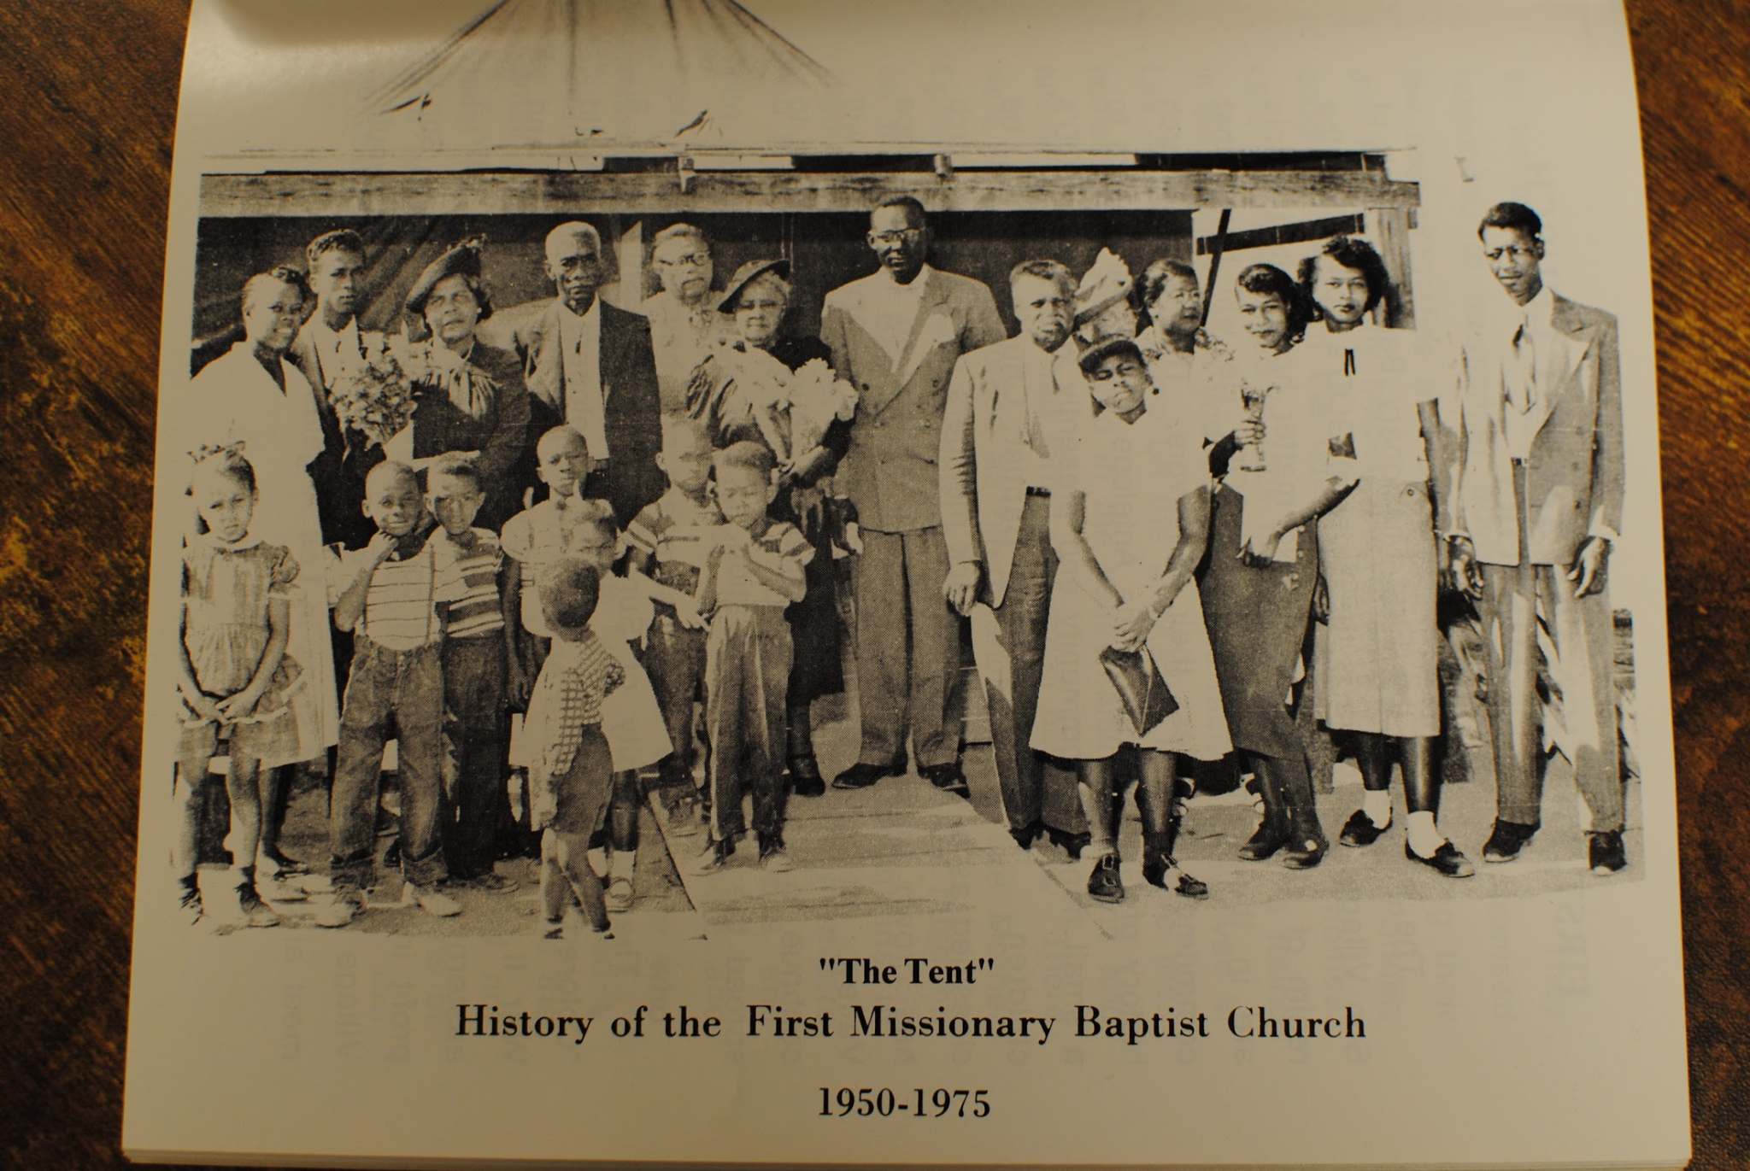

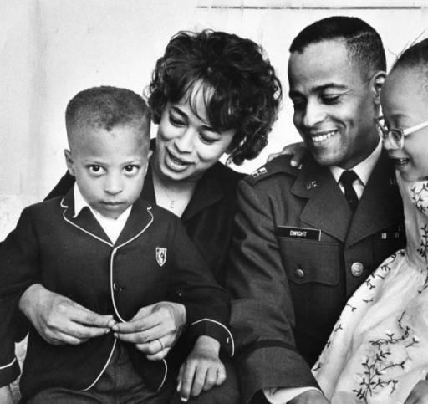*Image 2: New astronaut Ed Dwight poses with wife and children, 1963. Los Angeles Public Library Photo Collection. https://calisphere.org/item/69db81fd6180ff9dc5d8a1e9daad7aa7/*



*Image 3: Aerial view of Jackie Robinson Park, County of Los Angeles Department of Public Works, 07-22-1968 (In Copyright--Rights-Holder(s) Unlocatable or Unidentifiable.)*

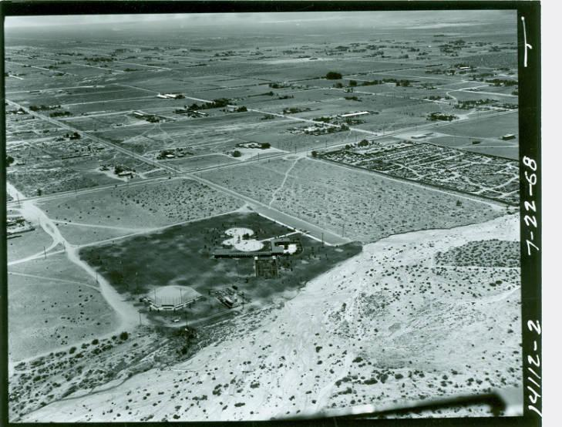

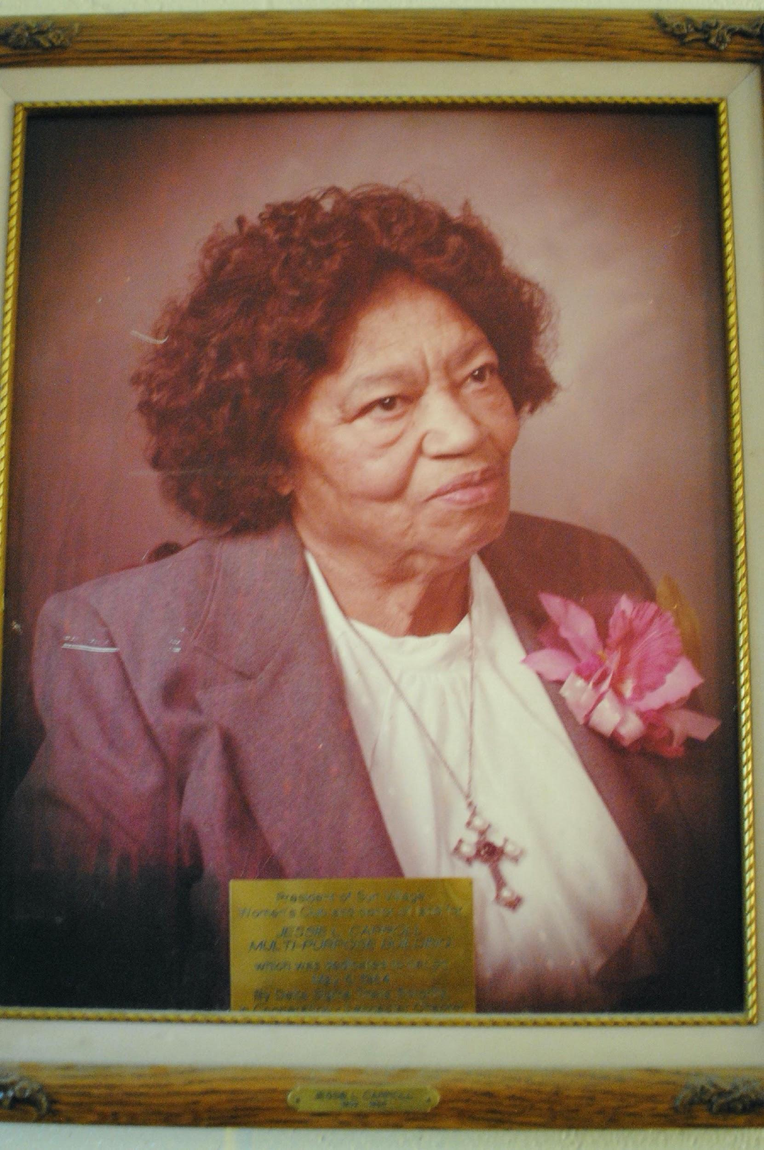

*Image 4. Portrait of Jessie L. Carroll, Jackie Robinson Park. Author's Photograph.*

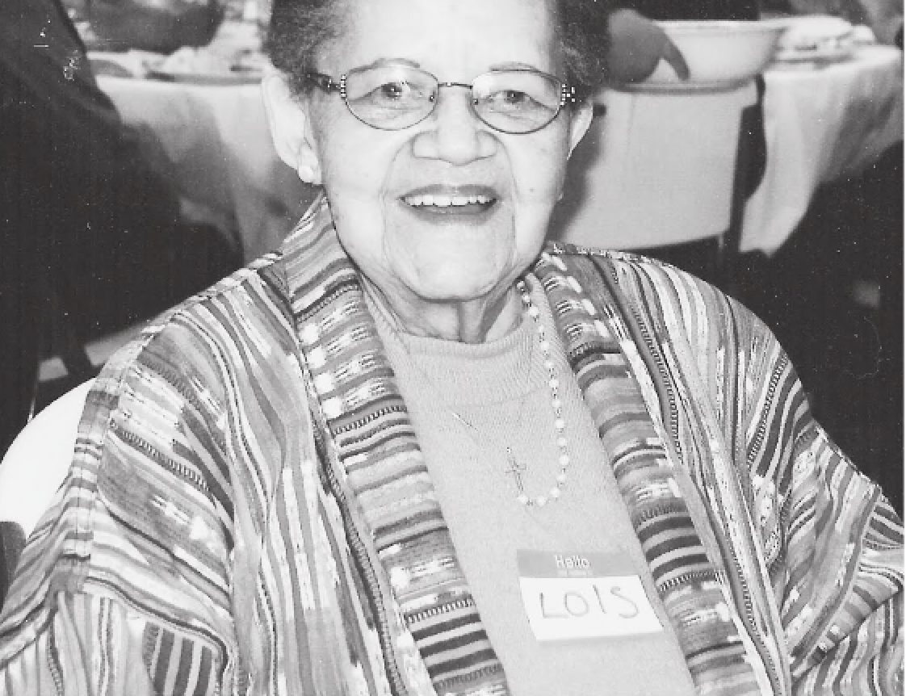

*Image 5. Lois Patton. Image from Norma Gurba*

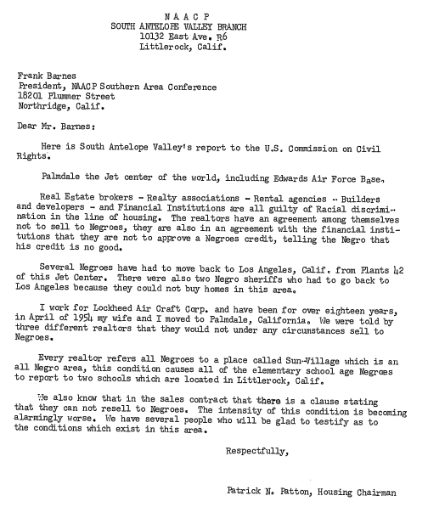

*Image 6: Patrick N. Patton Letter to Frank Barnes, 1960.*

*Image 7: Daisy Lee Gibson.*[*https://www.findagrave.com/memorial/103233857/daisy-lee-gibson/photo*](https://www.findagrave.com/memorial/103233857/daisy-lee-gibson/photo) 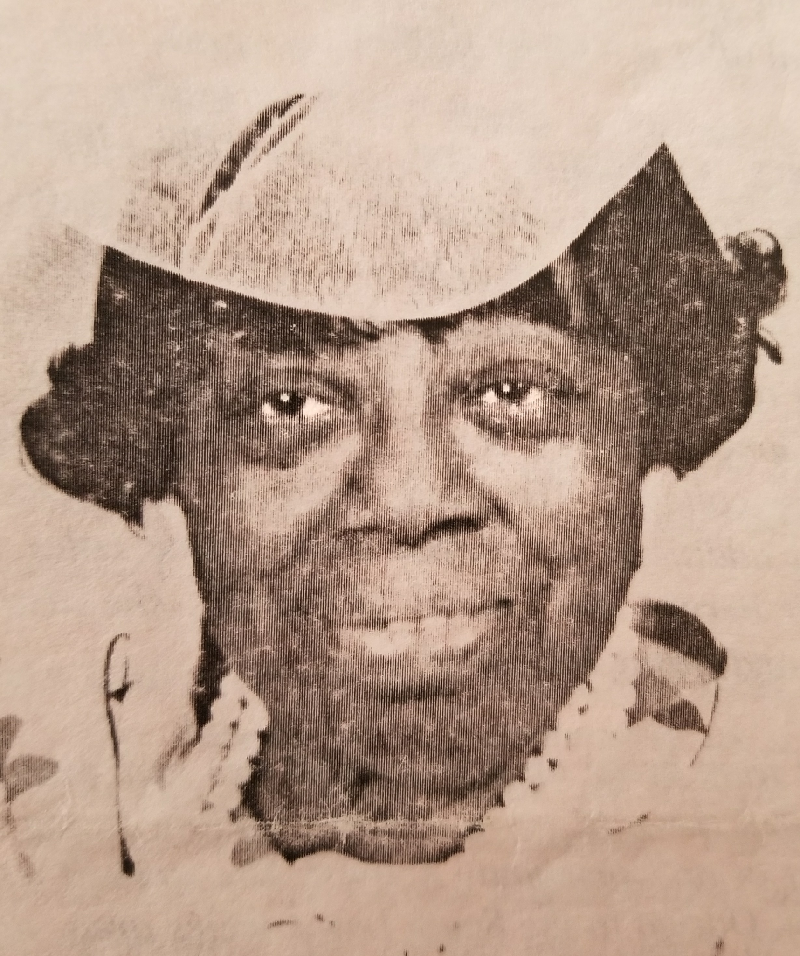

1. Today, roughly 20,000 people live in Rosamond. The city now sits just across the Los Angeles County line in Kern County.
2. Thomas C. Mcclintock, "James Saules, Peter Burnett, and the Oregon Black Exclusion Law of June 1844." *The Pacific Northwest Quarterly* 86, no. 3 (1995): 121-30. [www.jstor.org/stable/40491550](http://www.jstor.org/stable/40491550).
3. Wysinger v. Crookshank, 82 Cal. 588, 23 P. 54, (1890)
4. See <http://www.rosamondca.us/history/Graves.htm> for more history related to Charles Graves.
5. Davis, Mike. *City of Quartz: Excavating the Future in Los Angeles*. Verso Books, 2006.
6. Davis 2006, p. 4
7. Davis 2006, p. 6
8. Allensworth: <https://www.blackpast.org/african-american-history/history-allensworth-california-1908/>; <https://roadtrippers.com/magazine/colonel-allensworth-state-park/>

   San Bernardino: <https://www.sbsun.com/2016/02/22/cajon-pass-brought-first-black-pioneers-to-san-bernardino-valley/>

   Indio:

   <https://www.kcet.org/socal-focus/african-americans-shaping-the-california-desert-coachella-valley>

   Graves was by no means alone; journalist Delilah L. Beasley documented Black homesteaders creating communities across the Mojave Desert and Victorville during the early 1900s. As she wrote in her 1919 *The Negro Trailblazers of California*, “The deserts of California, namely the Mojave and at Victorville, are government lands, and quite a few colored people have taken up homesteads on this land and are improving them.” <https://www.kcet.org/socal-focus/african-americans-shaping-the-california-desert-homesteading-in-the-mojave>
9. Paul Robinson, “Race, Space, and the Evolution of Black Los Angeles,” in *Black Los Angeles: American Dreams and Racial Realities*, eds. Darnell Hunt and Ana-Christina Ramon (New York: New York University Press, 2010), 34.
10. Chris Clarke, “African-Americans Shaping the California Desert: Murray’s Ranch,” KCET, February 15, 2012, <https://www.kcet.org/socal-focus/african-americans-shaping-the-california-desert-murrays-ranch>, as well as Jennifer L. Thorton, “Remembering Bell Mountain: African American Landownership and Leisure in California's High Desert during the Jim Crow Era.” (PhD diss.,University of California, Riverside, 2018).
11. “The Historic Black Community of Bruce's Beach,” City of Manhattan Beach California, accessed August 10, 2022, <https://www.manhattanbeach.gov/home/showpublisheddocument/46745/637575505998870000>.
12. “The History of Bethel African Methodist Episcopal Church of Los Angeles,” Bethel African Methodist Episcopal Church of Los Angeles, accessed Ausust 10, 2022, <https://img1.wsimg.com/blobby/go/761b851e-08ef-4475-ac8d-bbbac2c945d7/downloads/The%20History%20of%20Bethel%20African%20%20%20Methodist%20Epis.pdf>.
13. City of Manhattan Beach, “Bruce’s Beach.”
14. Douglas Flamming, *Bound for Freedom* (Berkeley: University of California Press, 2005).
15. Today a senior center in Betty Hill’s name is located on the former site of the Bethel AME Church the Prioleaus built.
16. See United States Housing Act of 1937, Pub. L. No. 93-383, 88 Stat. 653 (1937) as well as Alex F. Schwartz, *Housing Policy in the United States*, (Routledge, 2014).
17. Donald Craig Parson, *Making a Better World: Public Housing, the Red Scare, and the Direction of Modern Los Angeles,* (Minneapolis: University of Minnesota Press, 2005), 18.
18. Parson, *Making a Better World*, 33.
19. Paul R. Williams was the architect of Pueblo Del Rio. Williams, the first Black member and fellow of the American Institute of Architects, designed timeless homes, public buildings, and churches throughout the city.
20. During this period, Jesse L. Terry became the first Black appointee to the housing commission. Jesse L. Terry Manor is named in her honor.
21. Parson, *Making a Better World,* 66.
22. Parson, *Making a Better World.*
23. Andrew Deener, *Venice: A Contested Bohemia in Los Angeles* (Chicago: University of Chicago Press, 2012)
24. Parson, *Making a Better World*, 47.
25. Parson, 91.
26. Ca. Const. art. XXXIV, § 1-4.

    https://leginfo.legislature.ca.gov/faces/codes_displayText.xhtml?lawCode=CONS&division=&title=&part=&chapter=&article=XXXIV
27. Kelly Lytle Hernández, *City of Inmates: Conquest, Rebellion, and the Rise of Human Caging in Los Angeles, 1771-1965* (Chapel Hill: University of North Carolina Press, 2017), .
28. Abraham Hoffman,“Angeles Crest: The Creation of a Forest Highway System in the San Gabriel Mountains,” *Southern California Quarterly*, 50, no. 3 (1968): 309-345, https://doi.org/10.2307/41170191.
29. Because the highway was also a route to mountain recreation, it was in high demand even before construction was finished. Abraham Hoffman reports that the forest highway had more users than the entire California National Parks system combined.
30. Roger Lotchin, *Fortress California 1910-1962: From Warfare to Welfare.* (New York: Oxford University Press 1992).196-197.
31. It was given that name in 1949, in honor of Captain Glen Edwards who had died in a crash there in 1948.
32. *South Antelope Valley (CA) Press*, February 11, 1943. Unlike the metropolis, Lancaster Homes was not repurposed into public housing after the war.
33. *South Antelope Valley (CA) Press*, August 1, 1946
34. *South Antelope Valley (CA) Press*, September 26, 1946
35. A note about Pancho Barnes as an example of the region’s aesthetic.
36. *South Antelope Valley (CA) Press*, June 5, 1952
37. *South Antelope Valley (CA) Press,* March 27, 1952
38. *South Antelope Valley (CA) Press,* August 14, 1952
39. *South Antelope Valley (CA) Press*, September 11, 1952
40. *South Antelope Valley (CA) Press*, July 30, 1953
41. *South Antelope Valley (CA) Press*, November 19, 1953
42. *South Antelope Valley (CA) Press*, March 25, 1954
43. Note to self - add Feather River Water Project
44. Sebastian Rotella, “Sun Village: Black Enclave Withers Amid Antelope Boom,” *Los Angeles Times*, August 27, 1989, https://www.latimes.com/archives/la-xpm-1989-08-27-me-1851-story.html.
45. Emily Ludolph, “Ed Dwight Was Set to Be the First Black Astronaut. Here’s Why That Never Happened,” *New York Times*, July 16, 2019, https://www.nytimes.com/2019/07/16/us/ed-dwight-was-set-to-be-the-first-black-astronaut-heres-why-that-never-happened.html.
46. Grubbs remained active in the community, sponsoring high school graduates’ educations at Antelope Valley Junior College, and supporting little league players in the area.
47. Ann Simmons, “Feeling burned in Sun Village; When the historically black community's high school became its neighbor's town meeting site, some old grievances resurfaced.” *Los Angeles Times*, September 24, 2012
48. *South Antelope Valley (CA) Press*, February 13, 1947
49. Valle Verde and Sun Village represent two moments of inter-racial solidarity when white landowners sold land to Black developers so that Black families could rent or purchase it without being bound by restrictive covenants.
50. Rotella, “Sun Village.”
51. *Los Angeles Times*, February 6, 1950
52. *Los Angeles Sentinel*, October 28, 1954
53. Ann M. Simmons, “For Sun Village and Littlerock, Historic Distrust Persists,” *Los Angeles Times*, September 23, 2012, <https://www.latimes.com/local/la-xpm-2012-sep-23-la-me-sun-village-20120924-story.html>
54. Rotella, “Sun Village.”
55. Daniel Martinez HoSang, *Racial Propositions: Ballot Initiatives and the Making of Postwar California* (Berkeley: University of California Press, 2010),
56. Ann M. Simmons, “Feeling Burned in Sun Village; When the Historically Black Community's High School Became its Neighbor's Town Meeting Site, Some Old Grievances Resurfaced,” *Los Angeles Times*, September 24, 2012, sec. A.1.
57. Records of the National Association of Colored Women's Clubs, 1895-1992, Part 1: Minutes of National Conventions, Publications, and President's Office Correspondence
58. “County Buys Land Near Sun Village,” *Valley Times* (North Hollywood, CA), March 7, 1958
59. Dorn and Robinson were classmates in high school in Pasadena.
60. “Honor ‘Jackie’ Robinson in Naming Park.” The Valley Times (North Hollywood, CA) January 11, 1960
61. Hudson, 2020. Pgs. 208-242
62. Robinson, 1995
63. “Blasts County ‘Deadwood’ in Budget,” *Valley News* (Van Nuys, CA), June 11, 1961; “County Board to Consider Corporate Levy Protests,” *Valley Times Today* (North Hollywood, CA), July 30, 1962; “City Slates ‘Jackie Day,’’ *Valley Times* (North Hollywood, CA), May 26, 1965.
64. “Jackie Robinson Park Summer Schedule Set,” *Antelope Valley (CA) Press*, June 26, 1966.
65. Board meeting minutes, including organization activities. Papers of the NAACP, Part 01: Supplement, 1956-1960
66. https://www.chapelofthevalleymortuary.com/obituary/Lois-Patton
67. *South Antelope Valley (CA) Press*, October 31, 1957.
68. Simmons served as the NAACP Field Secretary for the Southern California Region during this period. In later years, she became the NAACP’s National Education Director, led civil rights opposition to the appointment of William H. Rehnquist to the Supreme Court, helped pass federal recognition of the Martin Luther King Jr. Holiday, and campaigned for the passage of sanctions legislation targeting the apartheid government of South Africa.
69. *South Antelope Valley (CA) Press*, February 25, 1962.
70. California publications related to the President's Committee on Migratory Labor Folder: 101141-016-0001 Date: Jan 01, 1933 - Dec 31, 1962 Found in: Papers of the President's Committee on Migratory Labor, Part 1: Correspondence with States, 1955-1963 101141_016_0001_From_1_to_695
71. Althea T. L. Simmons, Field Secretary reports, 1963-1964 Folder: 009055-035-0701 Date: Jan 01, 1963 - Dec 01, 1964 Found in: Papers of the NAACP, Part 25: Branch Department Files, Series D: Branch Department General Department Files, 1956-1965
72. Facing a shortage of farmworkers, local growers in the valley appealed to the USDA War Board for assistance, developing a scheme by which the US Employment Service would locate farmworkers willing to move to the valley, either from other states or from Mexico. Farm owners would pay a fee to the government per worker relocated by the federal agency ($10 per US worker, $5 per worker from Mexico).
73. Officers' reports and Fiftieth Annual Convention of California State Federation of Labor held at Santa Barbara Folder: 000986-004-0010 Date: Aug 25, 1952 - Aug 29, 1952 Found in: State Labor Proceedings: AFL, CIO, and AFL-CIO Conventions, 1885-1974
74. Officers' reports and Fifty-Fourth Annual Convention of California State Federation of Labor held at Long Beach Folder: 000986-005-0001 Date: Aug 13, 1956 - Aug 17, 1956 Found in: State Labor Proceedings: AFL, CIO, and AFL-CIO Conventions, 1885-1974
75. Officers' reports and Fifty-Fifth Annual Convention of California State Federation of Labor held at Oakland. Folder: 000986-005-0008 Date: Sep 16, 1957 - Sep 20, 1957 Found in: State Labor Proceedings: AFL, CIO, and AFL-CIO Conventions, 1885-1974
76. *South Antelope Valley (CA) Press,* September 27, 1963
77. Althea T. L. Simmons, Field Secretary reports, 1963-1964 Folder: 009055-035-0701 Date: Jan 01, 1963 - Dec 01, 1964 Found in: Papers of the NAACP, Part 25: Branch Department Files, Series D: Branch Department General Department Files, 1956-1965
78. Althea T. L. Simmons, Field Secretary reports, 1963-1964 Folder: 009055-035-0701 Date: Jan 01, 1963 - Dec 01, 1964 Found in: Papers of the NAACP, Part 25: Branch Department Files, Series D: Branch Department General Department Files, 1956-1965
79. Althea T. L. Simmons, Field Secretary correspondence, January-June 1963 Folder: 009055-035-0201 Date: Jan 01, 1963 - Jun 01, 1963 Found in: Papers of the NAACP, Part 25: Branch Department Files, Series D: Branch Department General Department Files, 1956-1965
80. Need citation